|  |  |  |
| --- | --- | --- |
| Merchant User Guide | February 4  2019 | |
| This document is meant for the merchant guide of the system how processes take place and how ordering is done through foodni system. | | How foodni works |

TABLE OF CONTENTS

0 Preface – please read first 1

0.1 Purpose of this document 1

0.2 Use of this document 1

0.3 Function of User Guide 2

0.4 Production of User Guide 2

0.5 Forms of User Guide 2

0.6 Related documents 3

1 Introduction 4

1.1 Intended Readership 4

1.2 Applicability Statement 4

1.3 Purpose 4

1.4 How to Use this Document 4

1.5 Related Documents 4

1.6 Conventions 5

1.7 Problem Reporting Instructions 5

2 Overview 6

3 Instructions 7

4 Reference Section 9

A. Error Messages and Recovery Procedures 10

B. Glossary 11

C. Index 12

Document Control 13

Document Signoff 13

Document Change Record 13

0 Preface – please read first

0.1 Purpose of this document

1. This document is a generic document for use by Foodni operations and partners. It provides guidance and template material which is intended to assist Foodni Operations tea and Partner staff how to use the web and mobile platform. It is also useful background reading for anyone involved in developing or monitoring the application

0.2 Use of this document

1. Foodni merchants
2. Foodni internal technical and operations team
3. New technical resource onboarded into Foodni can leverage this document to understand the merchant functionality

|  |  |  |
| --- | --- | --- |
|  | Version | 1.0 |
|  | Date | Date of document (currently 17 January 2001) |

0.3 Function of User Guide

1. A is a document designed to help users and potential users of a system. But there are many possible variants within that. A may be

* a guide to the whole system or to a component package
* written before or after development
* designed primarily for training or for reference purposes
* intended for use by a designated type of user (See 1.1).

0.4 Related Documents

1. List all the documents referred to in this document

|  |  |  |  |  |
| --- | --- | --- | --- | --- |
| **Num** | **Title** | **Author** | **Date** | **Issue** |
|  |  |  |  |  |
|  |  |  |  |  |

# Overview

1. Foodni merchant registration is initiated by Foodni Admin. Log in as Foodni user and Go to 🡪Merchants🡪Merchant Lists🡪Create New Merchant

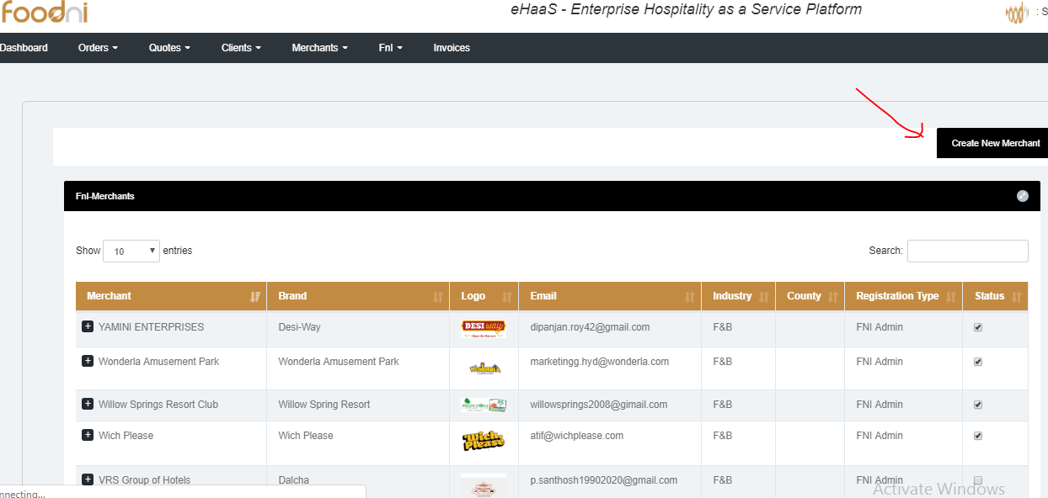

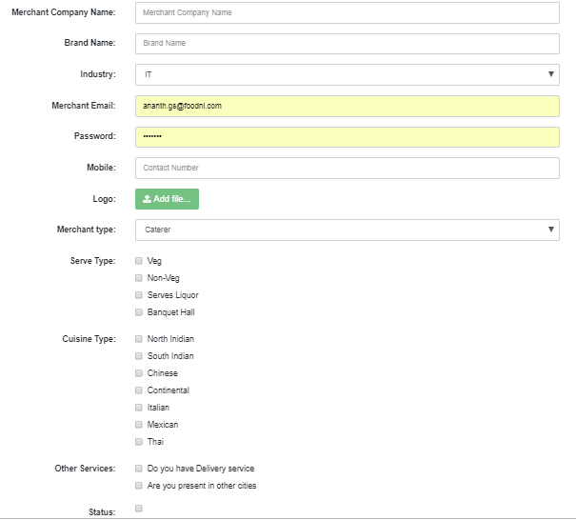

1. Upon creating the merchant activate the merchant by selecting status which send an email alert notification to merchant registered email id stating account is activated.
2. If merchant email id has to be changed drop an email to [support@foodni.com](mailto:support@foodni.com)
3. Once merchant user account is activated merchant can now login in and Merchant home page provides the dashboard of categories (Orders, Resort, Bookings, Quotes)
4. **Dashboard**

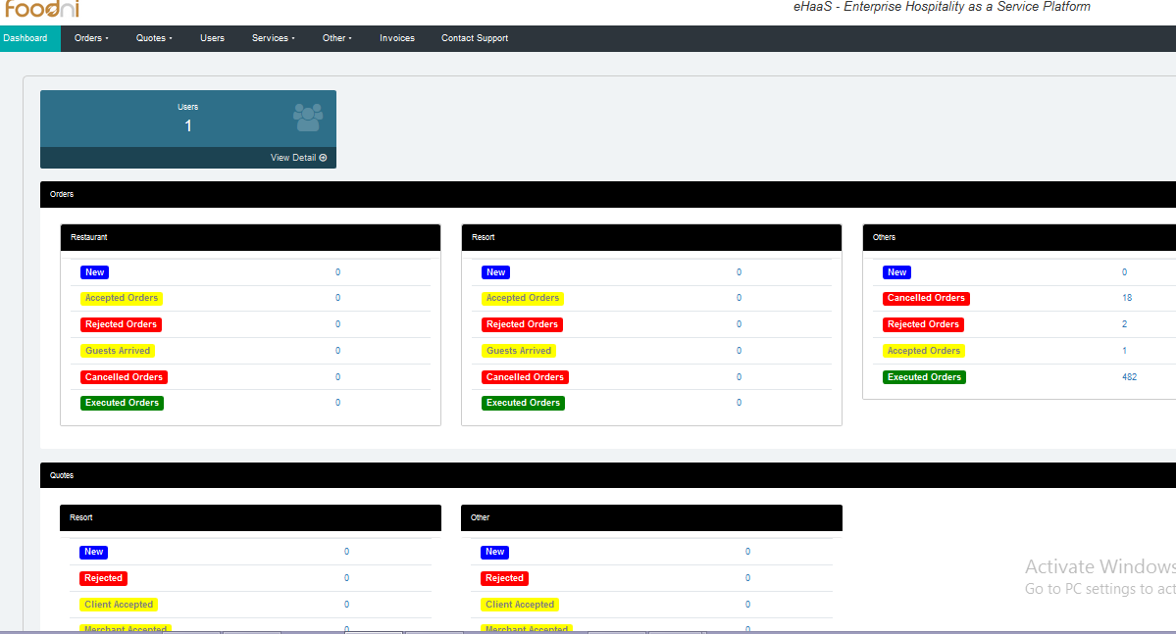

1. Go to services to setup where merchant can setup various services his outlet provides Restaurant, Delivery, Snacks, Lunch boxes, Resort etc by selecting the status check box which enables the service

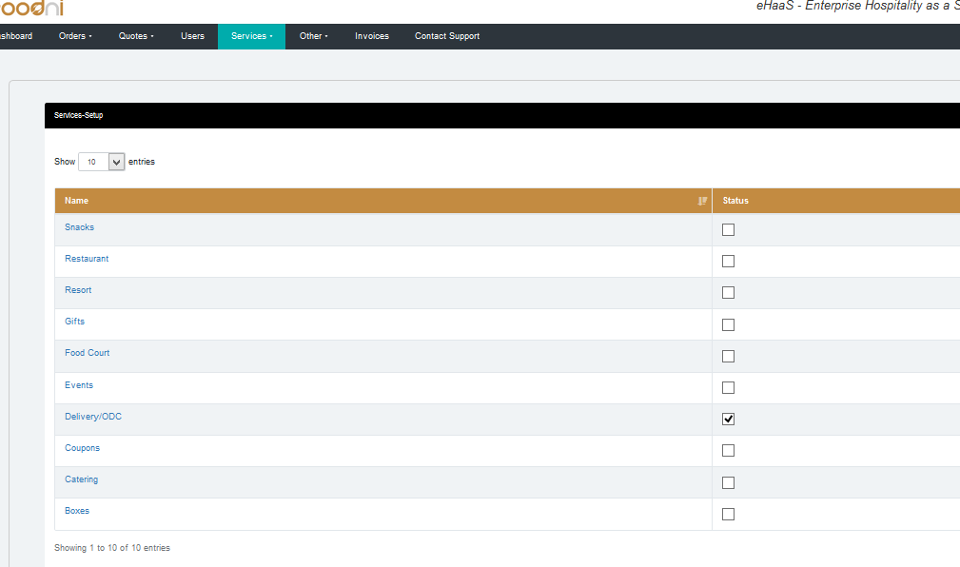

1. Setup Tax Structure: Go to services to setup where merchant can setup various types of taxes by selecting the status check box which enables the service.

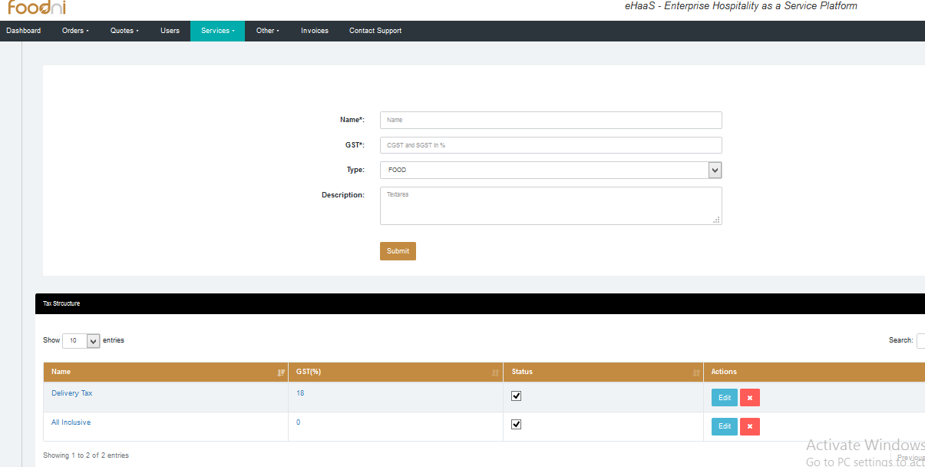

1. Setting up the business timings: Go to services to setup where merchant can setup the working hours and he can edit.

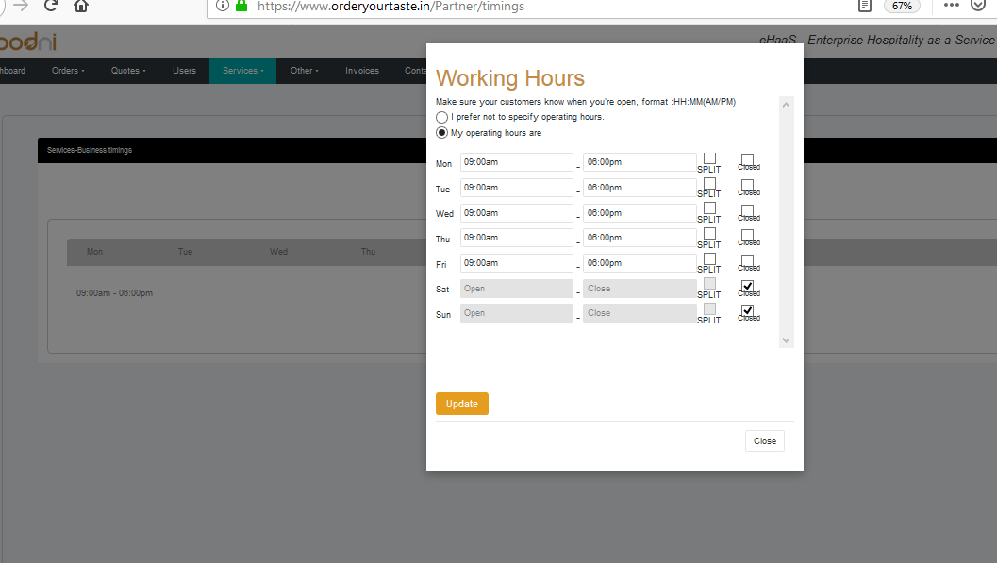

1. Setting up locations which is used be client track once the delivery upon enables the tracking. If location is not setup tracking functionality will not work.

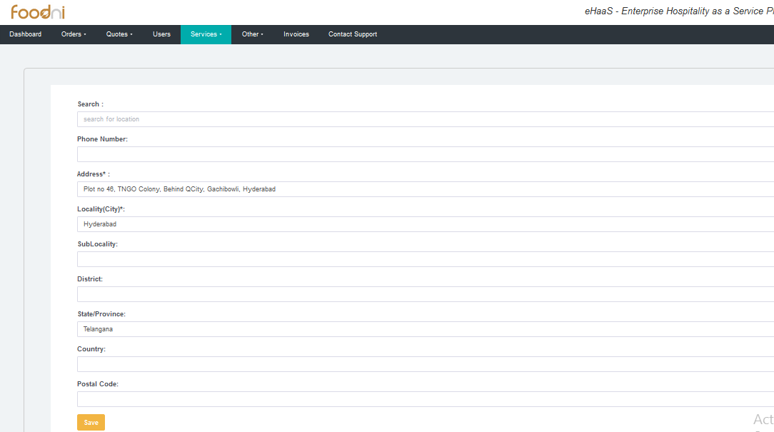

1. Go to services to setup where merchant can update merchant details, location/address, restaurant Booking details, delivery charges.

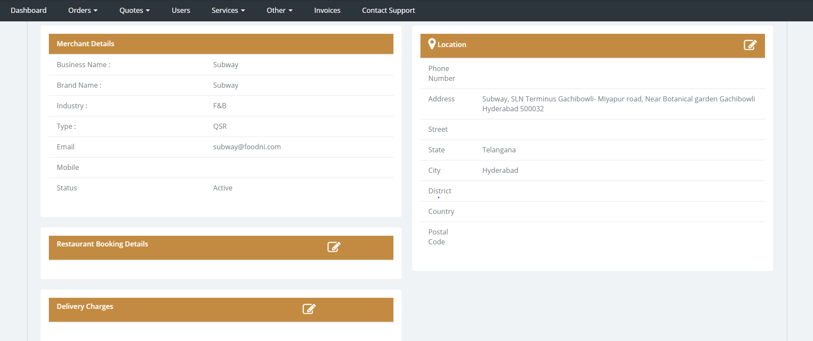

1. Merchant can manage reviews under Other 🡪Reviews where one can review the guest feedbacks and respond to client or delete the reviews if required

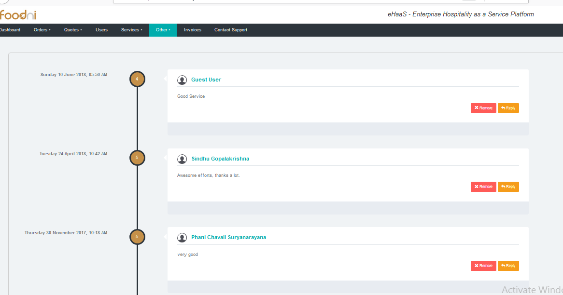

1. Setting up Restaurant interior images (Banner) and Menu Images (restaurant menus) go to Others🡪gallery🡪Banner Images (to upload Restaurant interior images client get to see) and Others🡪gallery🡪Menu Images (to upload Menu card images client can see what restaurant provides as alacarte)

Others🡪gallery🡪Banner Images🡪Create album by clicking onto Add New Album

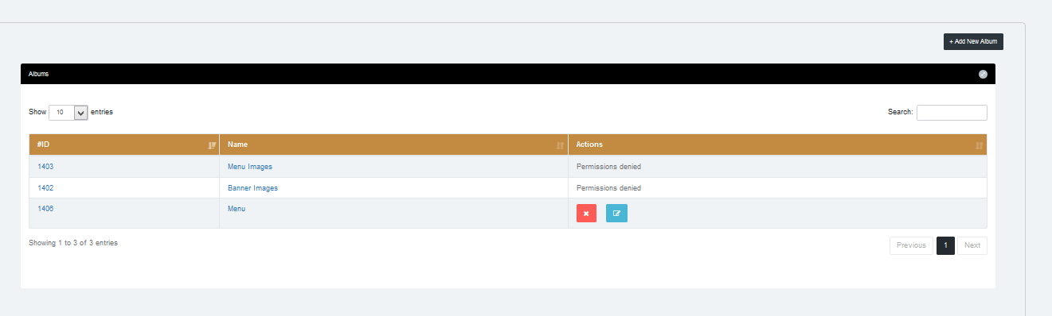

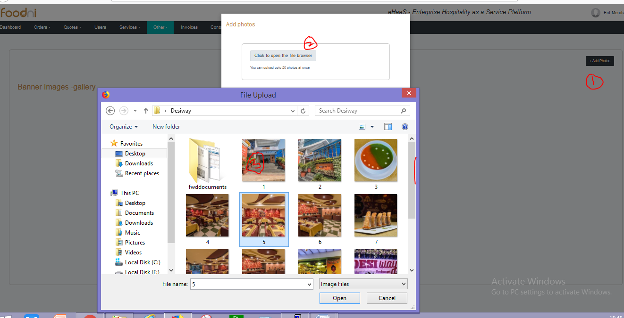

1. All statutory (GST, FSSAI License, Kitchen Audit Report & other) documents can be uploaded under Other🡪Certificates which client will get to view

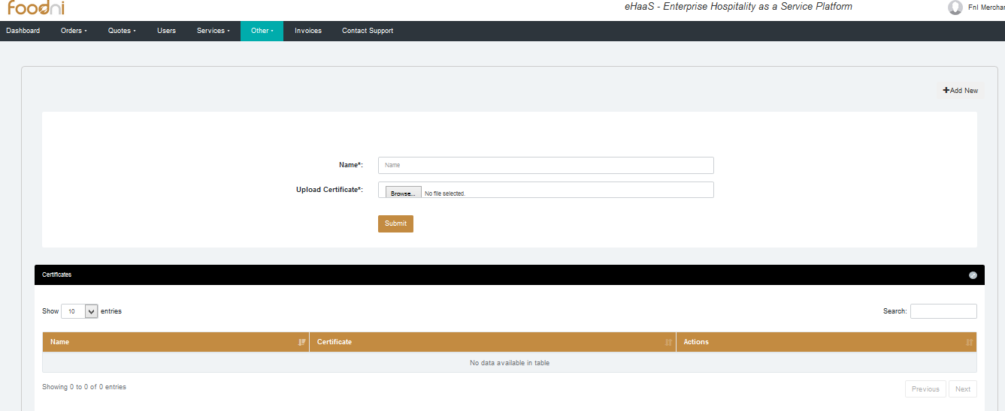

1. Under invoices Merchant can view, create, modify invoices.

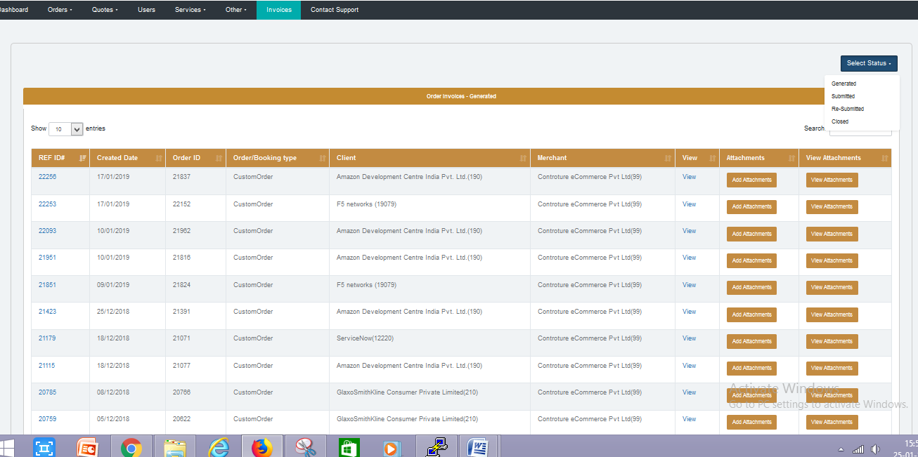

1. Search invoice based on invoice status like

1.Generated

2.submitted

3.re- submitted

4.closed

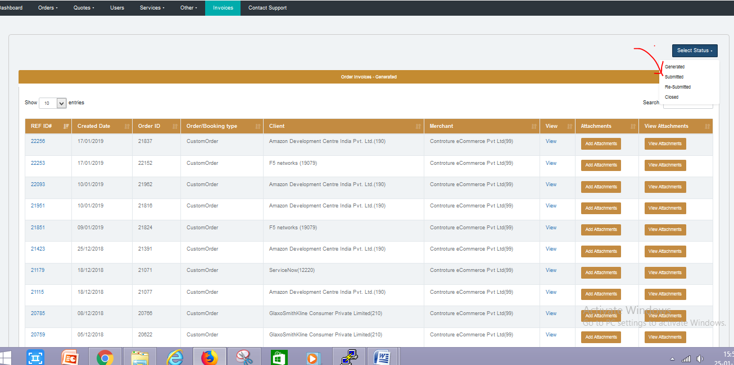

1. To edit, view, generate invoice log into merchant🡪go to invoices🡪 All invoice generated are displayed 🡪click onto RFID

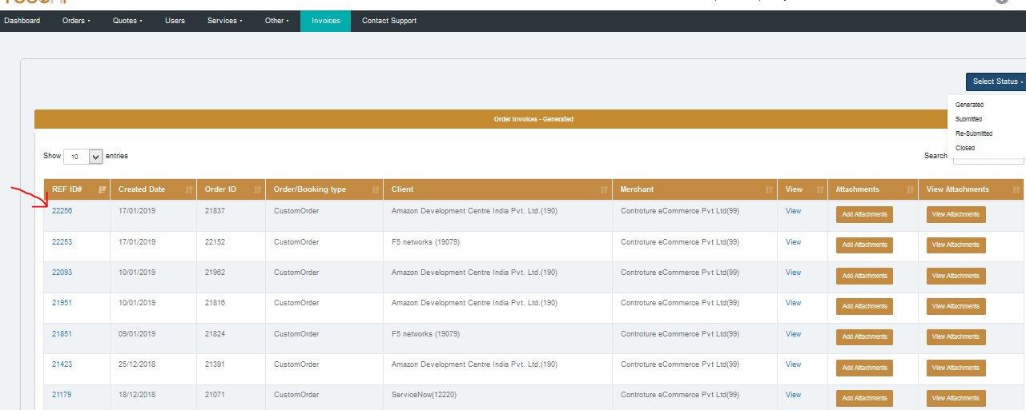

When you click on the rfid that will redirect to the following page and you can edit as you wish.

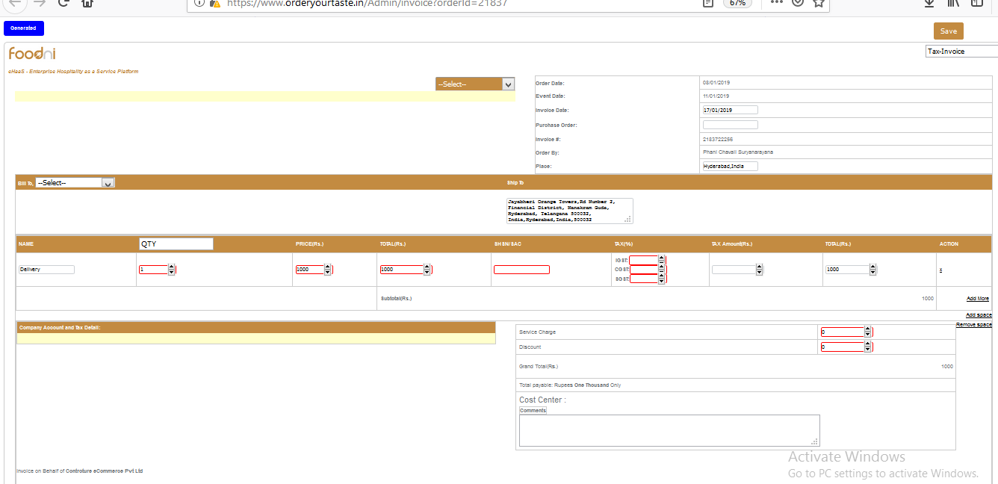

# Order

## Accept/Reject/Cancel

1. Login into Merchant🡪Go to Orders🡪click on Others to view all orders

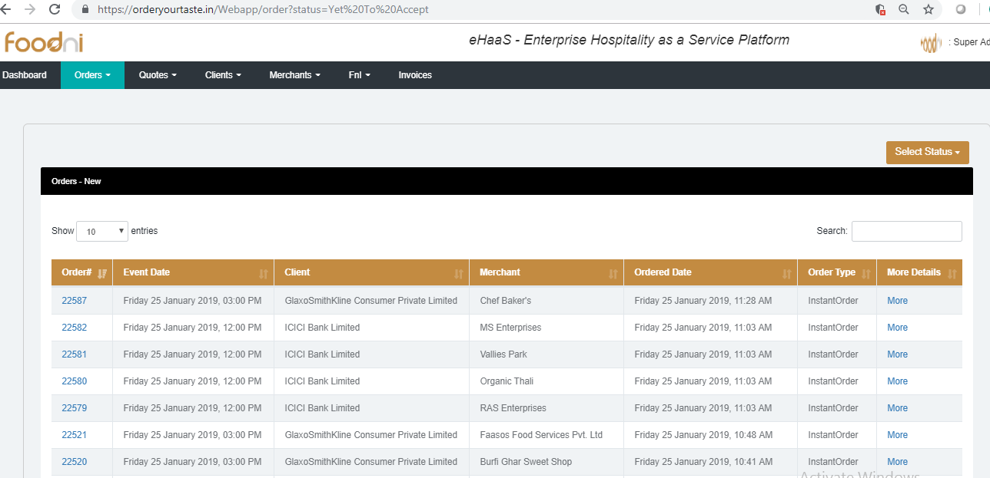

1. Login into Merchant🡪Go to Orders🡪Others. To view status by orders (New/Cancel/Accepted/Rejected/Executed) click onto select status filter

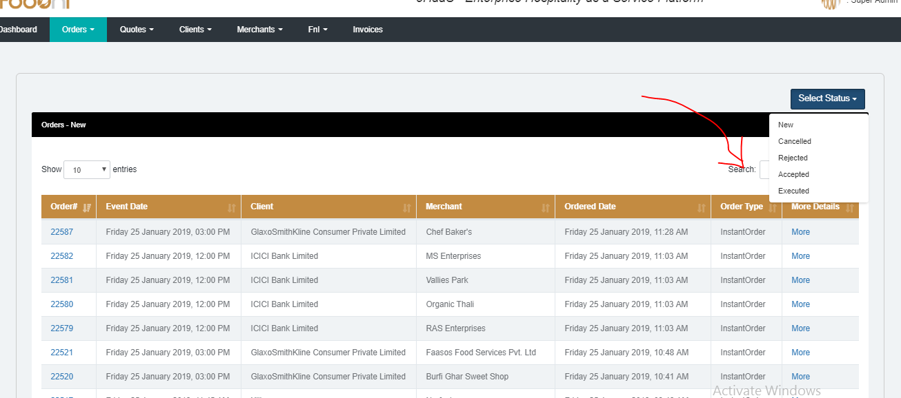

1. Login into Merchant🡪Go to Orders🡪Others 🡪click onto Order# which opens the order where merchant can cancel/reject, view order information including products to be delivered and the delivery location.

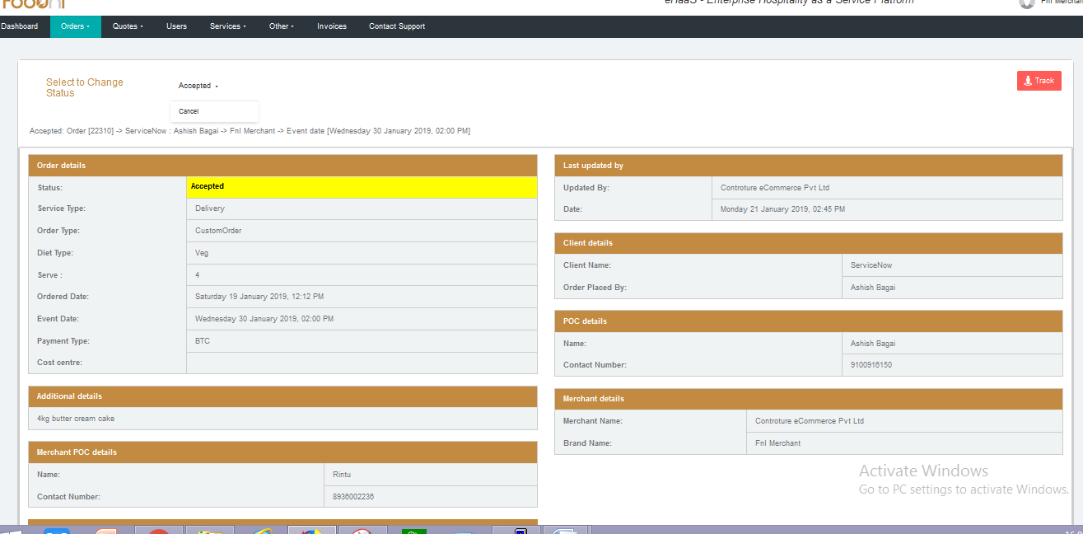

1. Similar to order we can perform same operations for restaurant and resort booking under Orders🡪Restaurants Orders🡪Resorts / Orders🡪others. The page as follows.

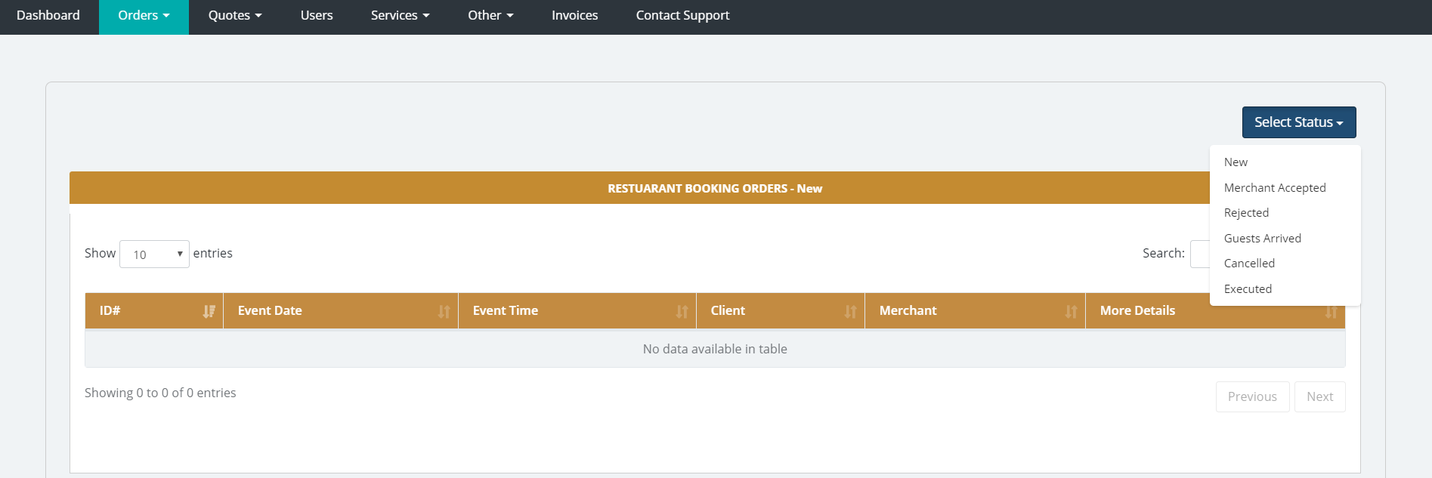

# Quotes

## Quotes Negotiation between client & merchant

### Similar to order we can perform same operations for restaurant and resort booking under Orders🡪Restaurants or Orders🡪Resorts

##### Did Login into Merchant🡪Go to Quotes🡪Others to view all instant order quotes (Box, Catering, Gifts, Lunchbox)

Login into Merchant🡪Go to Orders🡪Others. To view status by orders (New/Cancel/Accepted/Rejected/Executed/negotiate/order placed/merchant confirme) click onto select status filter

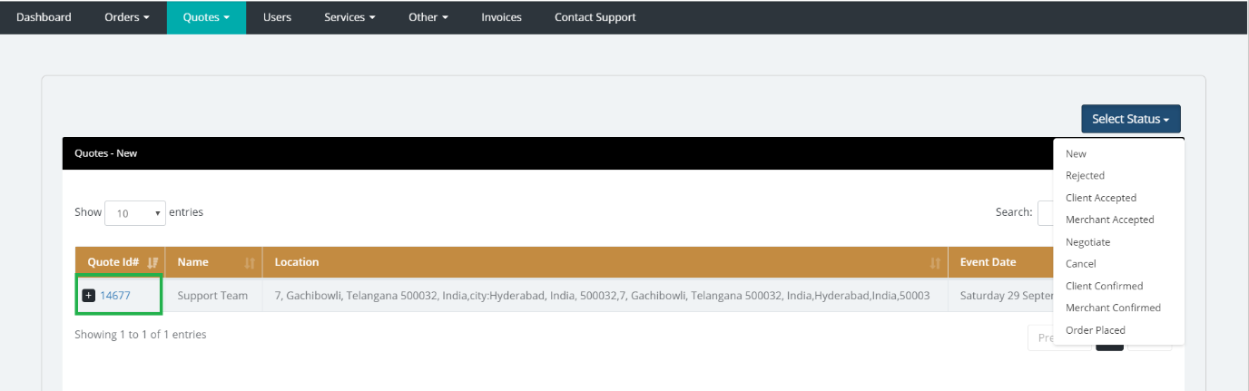

Merchant can see all the details of quote by clicking on the” Quote id” which is highlighted

Above. then the following page will appear.

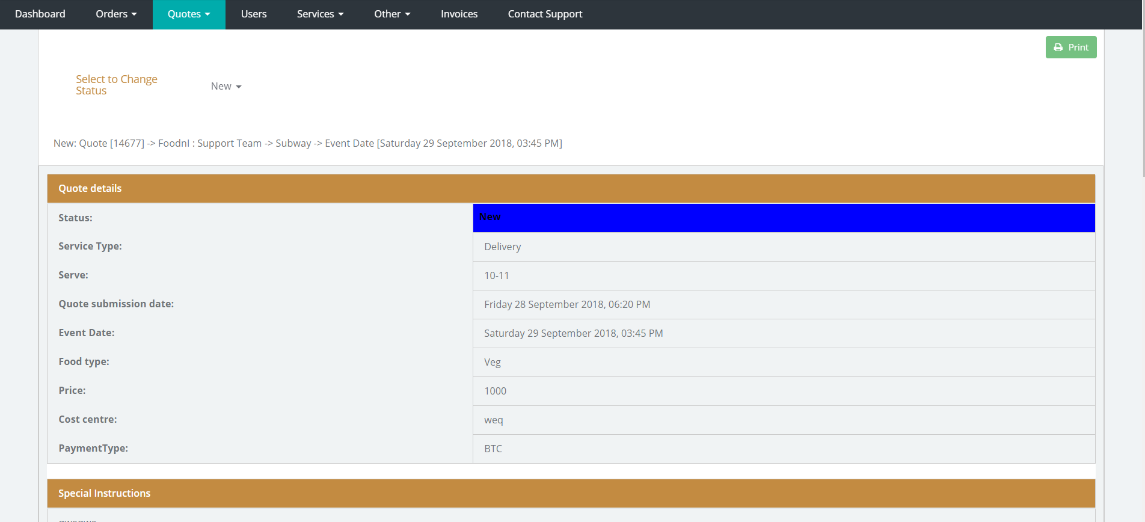

# users

#### 

##### Merchant admin can see the details of there users and users are added by the merchant admin so that who all are the users has the permission to access the account so they can see all the orders for particular merchant, can change the status or any order or quotes.

##### When merchant click on the users the following page will appear.

##### 

##### Merchant can add the new user by clicking on the create new account which is highlighted above then the following page will appear.

##### 

##### After entering all the details click on save.

# Instructions

##### **Standards to be followed by merchants**:

##### 1. Please take a printout of Delivery/Order challan from FnI platform and get it acknowledged [signed and/or stamped] for delivered Boxes or actual Pax by Client's Admin/POC, Security etc. In case of non-submission of Delivery Challan, Client will not process Invoice.

##### 2. Please upload your company compliance documents and update them whenever required to comply with ordering guidelines.

##### **Boxes/Delivery:**

##### 1. Menu should be pasted neatly on the Box.

##### 2. Veg & Non-Veg stickers should paste neatly on the Box.

##### 3. Make sure there is no spill over from the Box.

##### 4. Box should have Fork & Spoon, Paper Napkin, Toothpick, Mouth Freshener etc.

##### 5. Call / SMS client before starting for delivery without fail.

##### 6. Deliver food boxes in carton or thermcol sealed containers to fit appropriately.

##### 7. Make sure order is delivered 5 minutes before the delivery time.

##### 8. Use only FNI Corp approved Boxes type, Quality etc.

##### **Catering:**

##### 1. Menu printout should be kept near the plate picking area.

##### 2. Name tags should be kept in front of chafing dish with neatly pasted Veg & Non-Veg stickers.

##### 3. Make sure there is no spill over from the Chafing dishes.

##### 4. Fork & Spoon, Paper Napkin, Toothpick, Mouth Freshener etc should be part of Buffet setup.

##### 5. Soiled plates section should always be neat and clean.

##### 6. ODC Manager, Service boys should be wearing hand gloves, plastic/Chef head cover, chef aprons, neat and clean clothes/shoes.

##### 

B. Glossary

1. A glossary should be provided if the manual contains terms that users cannot be assumed to know, or that are ambiguous.
2. Optionally, at the discretion of the developers, the Glossary may be merged with the Index below, giving the reader a combined a statement of

* what the terms mean
* where in the document they are used (including perhaps where they are defined in more detail).

Document Control

|  |  |
| --- | --- |
| **Title:** |  |
| **Issue:** |  |
| **Date:** |  |
| **Author:** |  |
| **Distribution:** |  |
| **Reference:** |  |
| **Filename:** |  |
|  |  |

Document Signoff

|  |  |  |  |  |
| --- | --- | --- | --- | --- |
| **Nature of Signoff** | **Person** | **Signature** | **Date** | **Role** |
| Author |  |  |  |  |
| Reviewer |  |  |  |  |

Document Change Record

|  |  |  |  |
| --- | --- | --- | --- |
| **Date** | **Version** | **Author** | **Change Details** |
|  | Issue 1 Draft D |  | First issue for review |
|  | Issue 1 Draft E |  | Reviewed |
|  | Issue 1 Draft 6 |  | Corrected formatting |
|  | Issue 1 |  | Apply review comments and issue |